**CPSC-1030 Term Project Proposal**

**Fall 2017, Section M04**

1. **Web Site Description:**

* Grocery Store Website
* Duel Interface: Customer/User(Manager, Employee, Member)
* Graphic List of Product (Table Grid)
* Animated Advertisement Page

1. **Web Site Differentiation:**

* Site Comparison #1 (T&T supermarket):

|  |  |  |
| --- | --- | --- |
|  | **T&T Supermarket** | **DB Grocery Store** |
| Age | Middle Age-Elder | Teen-Young Adult |
| User | Customer | Customer/Employee |
| Structure | Hierarchy | Hierarchy |
| Color Scheme | Monochrome | Monochrome |
| Content | Graphic Base | Text Base/Table Display |

* Site Comparison #2 (Safeway):

|  |  |  |
| --- | --- | --- |
|  | **Safeway** | **DB Grocery Store** |
| Age | All Age | Teen-Young Adult |
| User | Customer | Customer/Employee |
| Structure | Hierarchy | Hierarchy |
| Color Scheme | Complementary | Monochrome |
| Content | Graphic Base | Text Base/Table Display |

* Site Comparison #3 (Safe On Foods):

|  |  |  |
| --- | --- | --- |
|  | **Safe On Foods** | **DB Grocery Store** |
| Age | Young Adult | Teen-Young Adult |
| User | Customer | Customer/Employee |
| Structure | Hierarchy | Hierarchy |
| Color Scheme | Analogous | Monochrome |
| Content | Graphic Base | Text Base/Table Display |

1. **Web Site Client:**

* DB Project Group
  + Yen-Hsiang(Brain) Lee
    - [ylee46@d2l.langara.bc.ca](mailto:ylee46@d2l.langara.bc.ca)
  + Zi-Yang(Arvin) You
    - [ayou02@d2l.langara.bc.ca](mailto:ayou02@d2l.langara.bc.ca)
  + Zhengliang(Puck) Wang
    - [zwang79@d2l.langara.bc.c](mailto:zwang79@d2l.langara.bc.c)

1. **Web Site Initial Design and Wireframe:**

* Wireframe Layout:
  + Customer Layout:

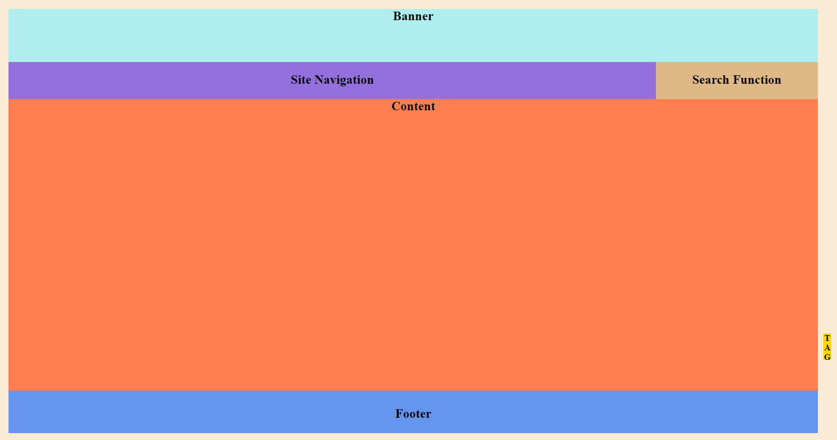

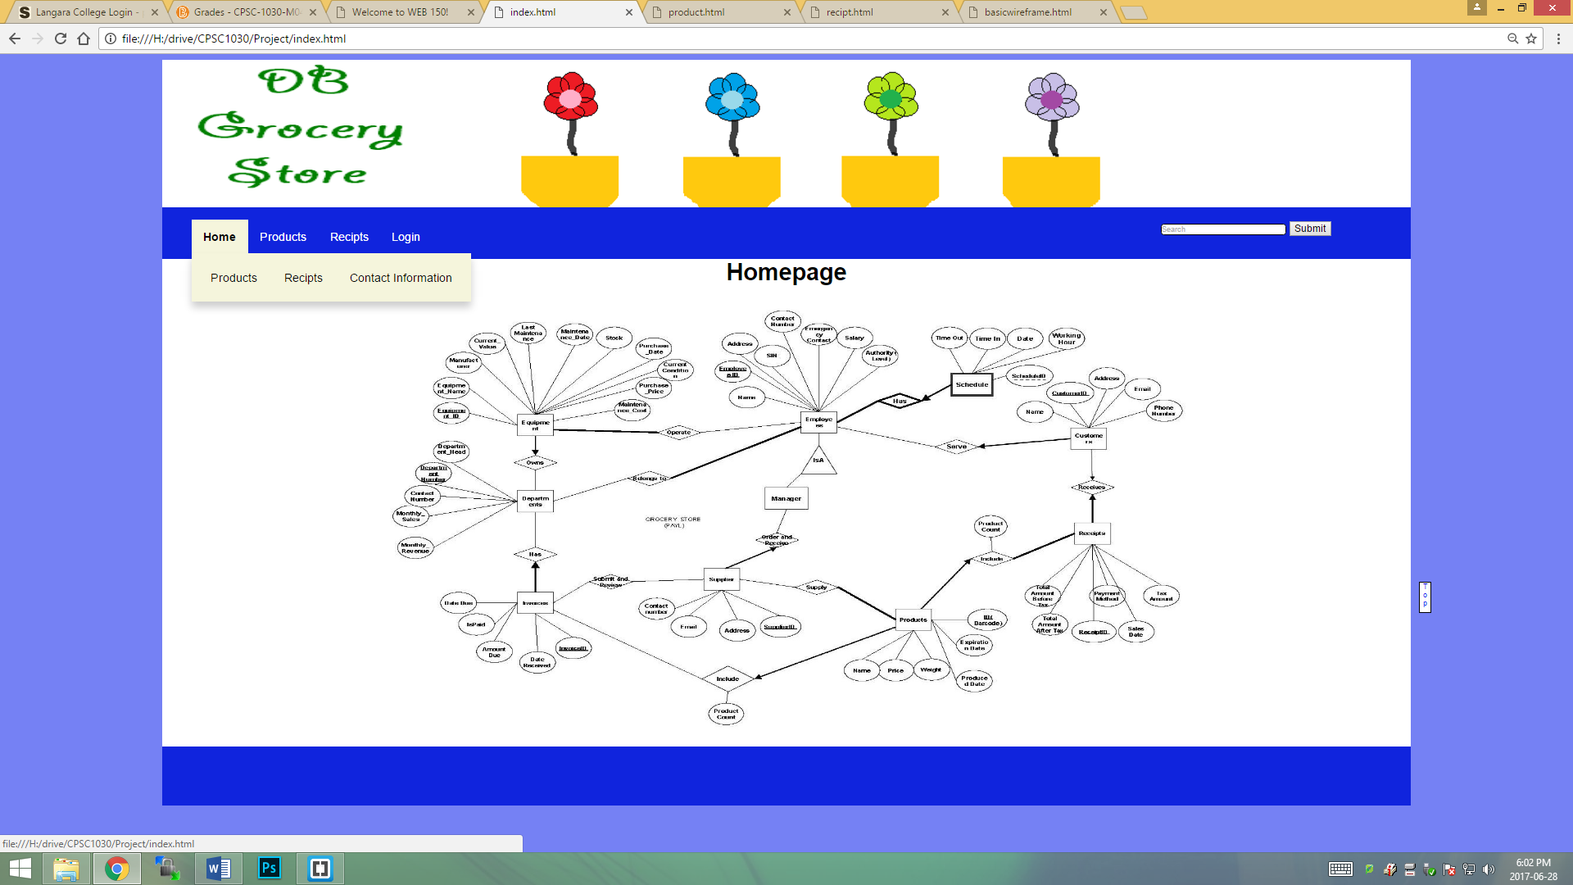

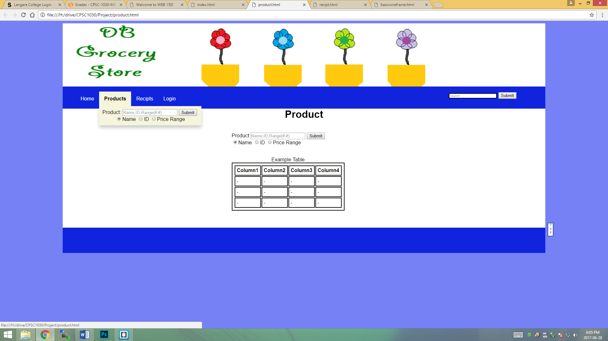

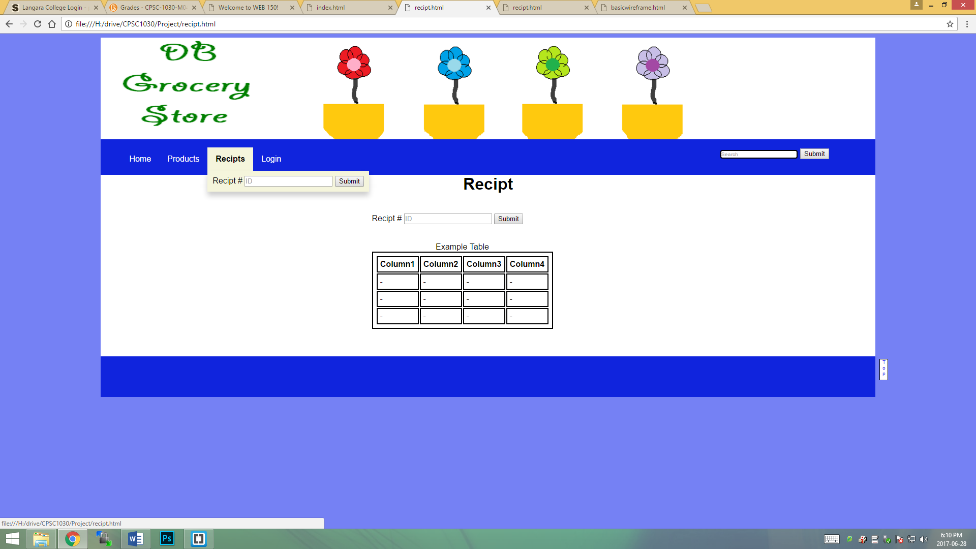

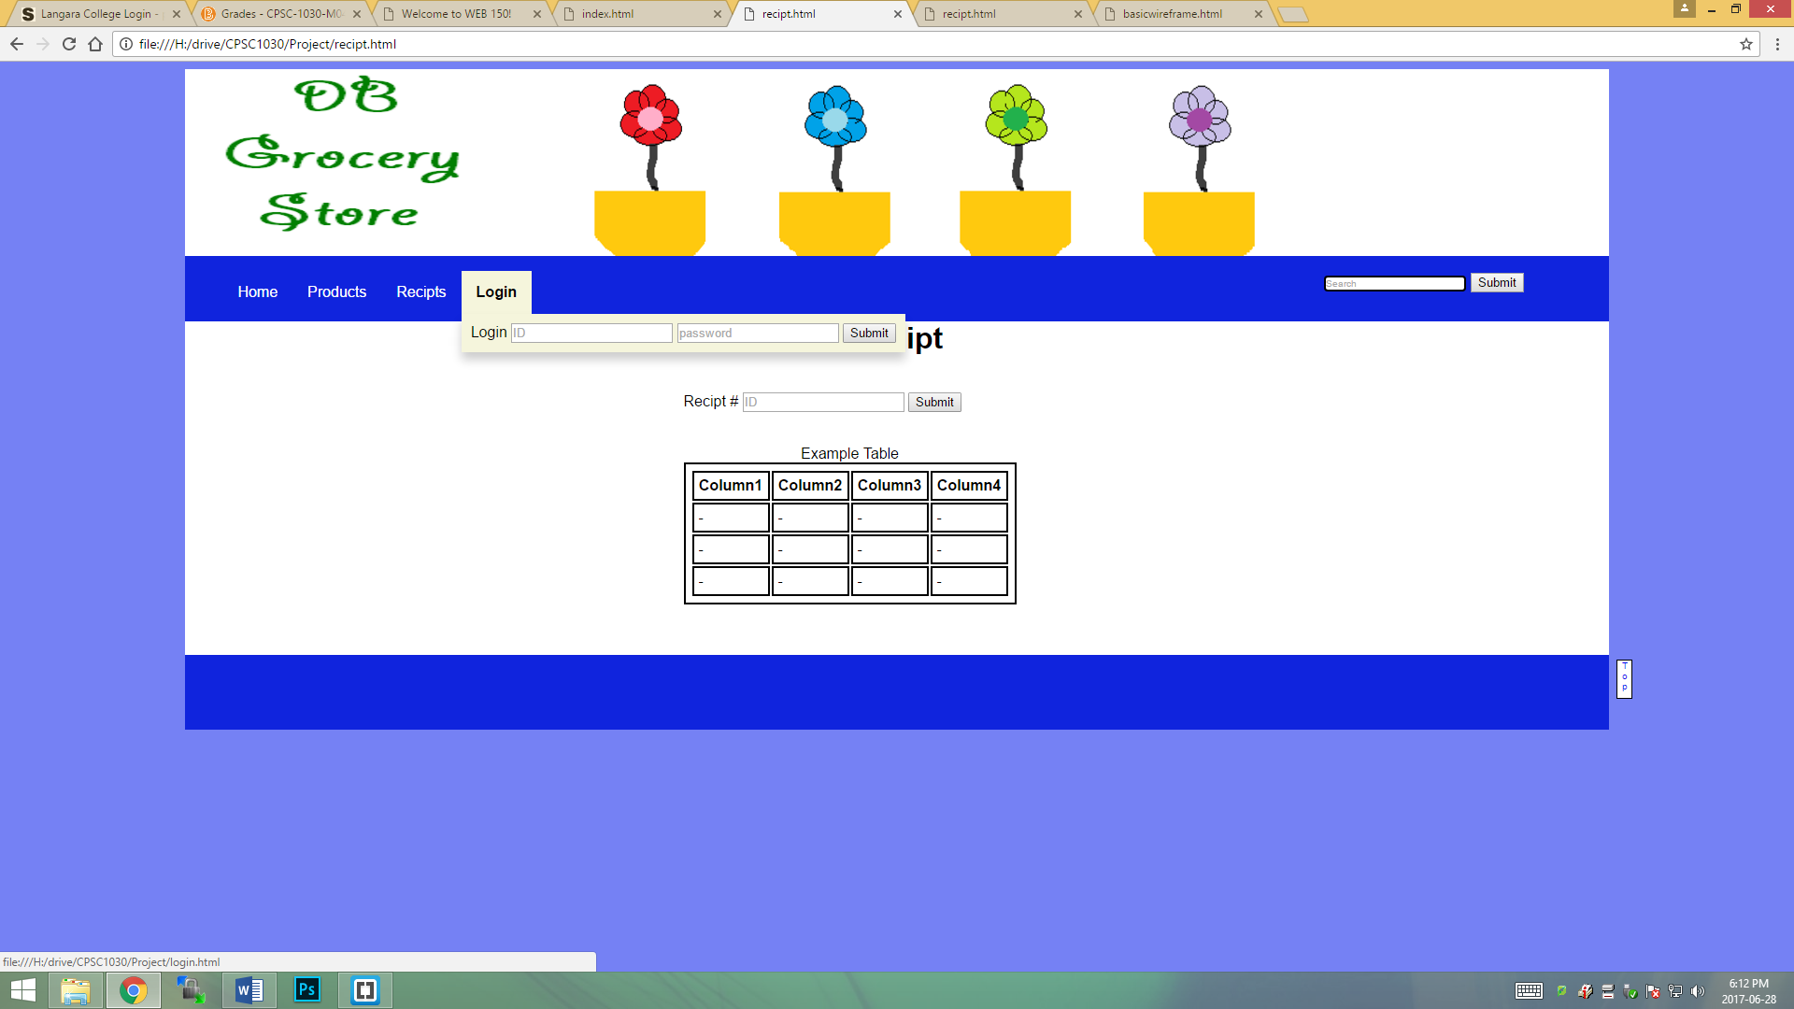

* + User Layout:

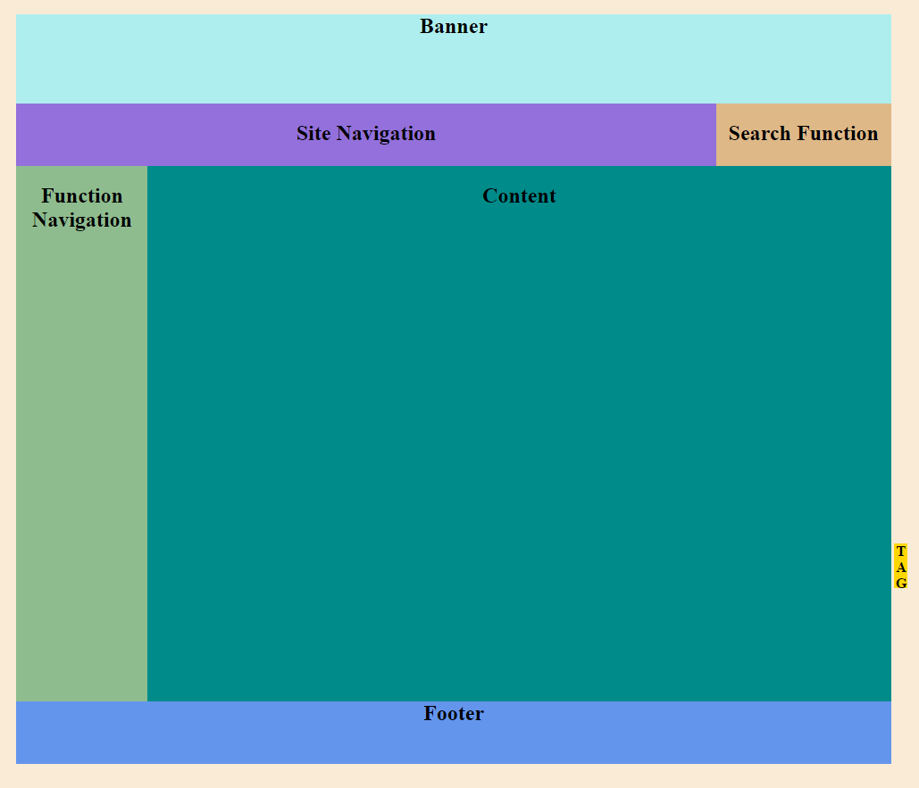

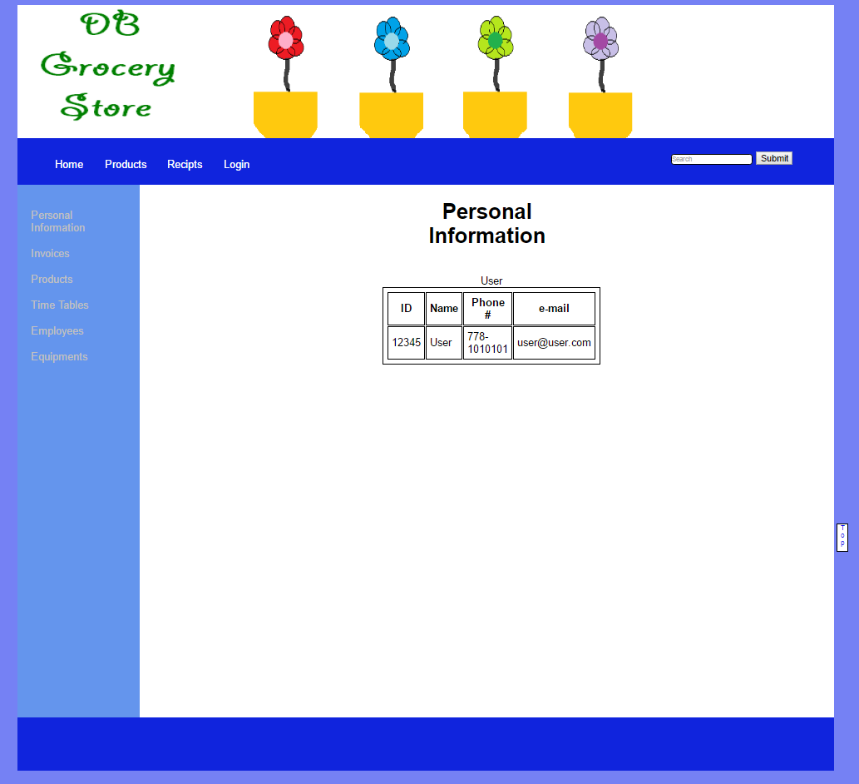

* Color Scheme : Monochrome
* Font -Family: Arial, Times New Roman, sans-serif;

1. **Supported Browsers:**

* Google Chrome
* IE Explorer
* Firefox
* Safari

1. **Development Tools:**

* Bracket
* Apache
* PHP
* Gimp/Photoshop